Project Development Phase
Model Performance Test
Date | 03 October 2026
Team ID | SWUID2026355799
Project Name | Streamlining IT Procurement: Automating Standard Laptop Orders with Flow Designer
Maximum Marks
Model Performance Testing
Project team shall fill the following information in the model performance testing template. The content is taken from the supplied main problem statement.
S.No. | Parameter | Values | Screenshot
1 | Model Summary | ServiceNow Flow Designer automation for standard laptop procurement. The workflow creates a Catalog Task after approval, updates the short description and description, assigns the task to the Hardware group, and supports timely laptop configuration. The flow is named “Standard laptop task”, uses a Service Catalog trigger, and creates a Catalog Task with Approval = Approved and Assignment group = Hardware. | Fig. 1–3
2 | Accuracy | Not specified in the provided problem statement. No training accuracy, validation accuracy, or numerical model-accuracy metric is given. | N/A
3 | Confidence Score (Only YOLO Projects) | Not applicable. This is a ServiceNow Flow Designer automation project, not a YOLO object-detection project. | N/A
Problem Statement Basis
The current IT procurement process lacks efficiency and automation, resulting in delays and manual overhead, particularly in handling standard laptop orders. Standard laptop requests often require configuration, but this step is prone to oversight or delay, leading to frustration among users and inefficient resource allocation within the IT department.
User Story
As a member of the IT procurement team, the goal is to streamline standard laptop ordering so tasks are automatically generated and assigned to the Hardware team for configuration, ensuring laptops are promptly configured upon arrival and reducing user wait times and manual intervention.
Project Objective
- Create a seamless experience for users requesting standard laptops by ensuring timely configuration.
- Reduce manual intervention and potential errors in the procurement process.
- Improve resource utilisation within the IT department by optimising task allocation.
- Enhance overall efficiency and productivity in IT procurement operations.

Implementation Screenshots / Evidence

Screenshots below are extracted from the supplied project document and correspond directly to the documented workflow.
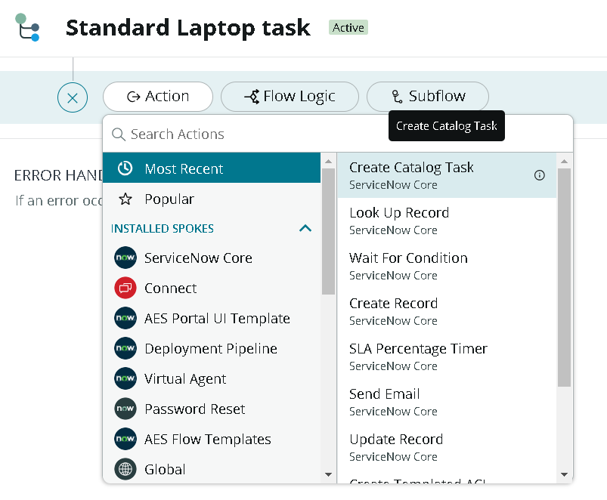
Figure 1. Flow Designer – “Standard laptop task” with the Create Catalog Task action.
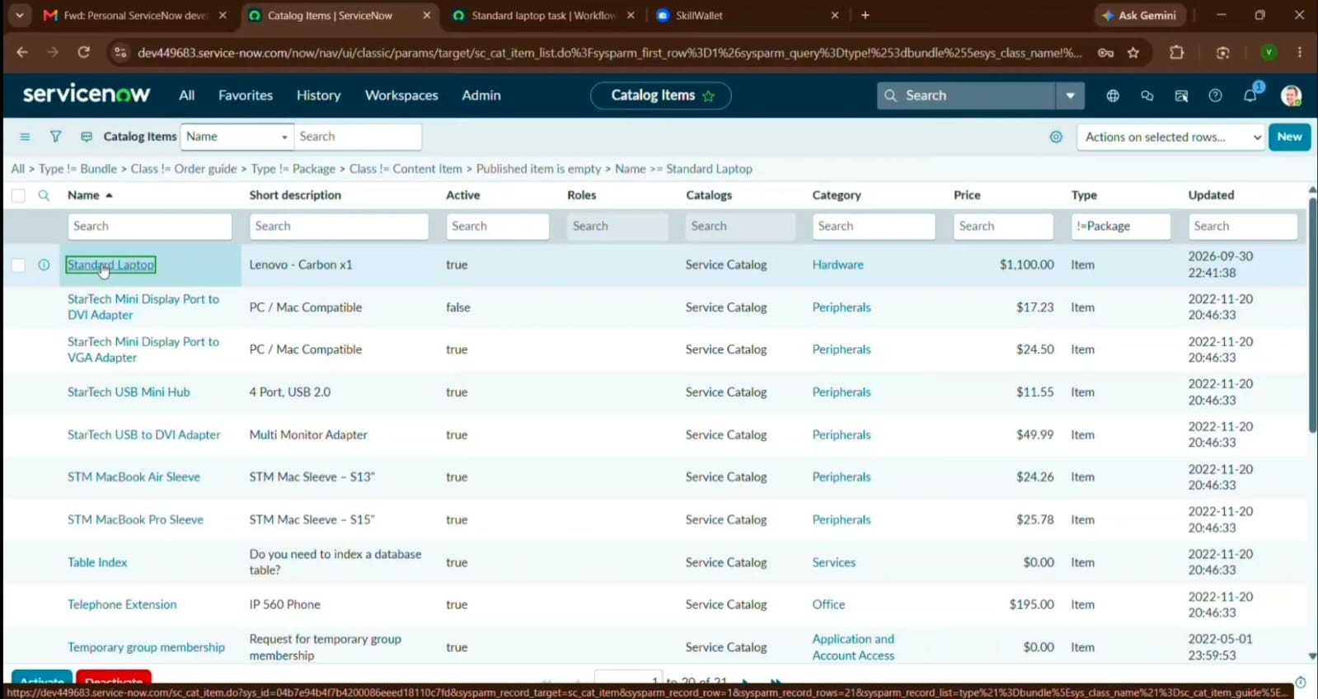
Figure 2. ServiceNow Catalog Items – Standard Laptop item under the Hardware category.

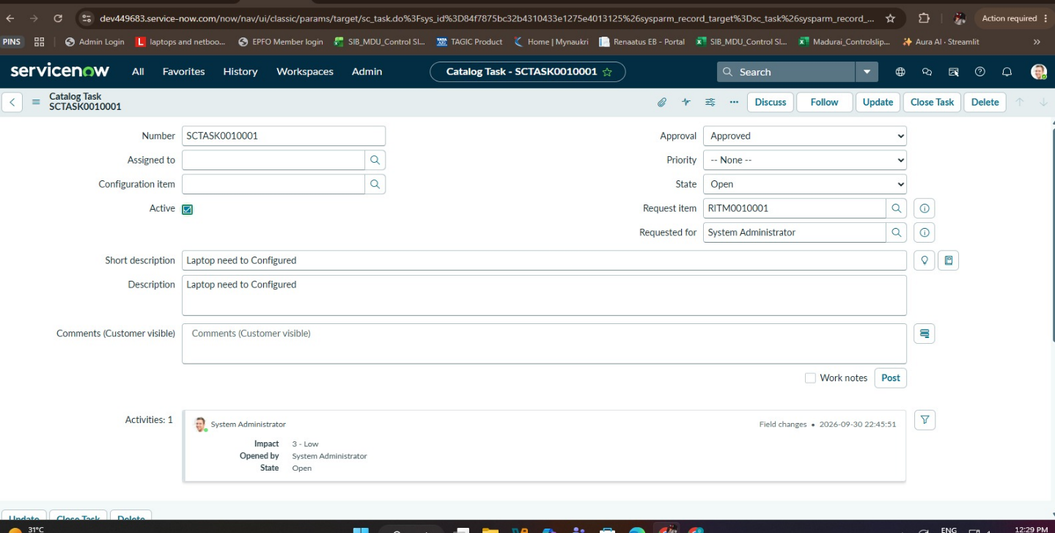

Figure 3. Resulting Catalog Task showing Approval = Approved and “Laptop needs to Configured”.
Conclusion
By automating the standard laptop procurement process with ServiceNow Flow Designer, the project addresses inefficiencies and reduces manual overhead. The workflow supports timely configuration, minimises user wait times, optimises resource allocation, and improves productivity within the IT department.

User Acceptance Testing (UAT) Template
Date | 03 October 2026
Team ID | SWUID2026355799
Project Name | Streamlining IT Procurement: Automating Standard Laptop Orders with Flow Designer
Maximum Marks | 10 Marks
Project Overview:
Project Name: Streamlining IT Procurement: Automating Standard Laptop Orders with Flow Designer
Project Description: ServiceNow Flow Designer automates standard laptop procurement, approval, catalog-task creation, and assignment to the Hardware group for configuration.
Project Version: 1.0
Testing Period: To be completed during User Acceptance Testing
Testing Scope:
- Standard Laptop request through Service Catalog.
- Service request approval.
- Automatic Catalog Task creation after approval.
- Short description and Hardware assignment group update.
- Timely configuration and reduced manual intervention.
Testing Environment:
URL: https://dev449683.service-now.com/Location: ServiceNow / Flow Designer
Credentials: Not specified in the main problem statement
Test Cases:
Test Case ID | Test Scenario | Test Steps | Expected Result | Actual Result | Pass/Fail
TC-001 | Place Standard Laptop request | Service Catalog → Hardware → Standard Laptop → Order Now | Request is submitted and order status is displayed. | To be recorded during UAT | Pending
TC-002 | Approve request | Open Request Number → Approvers → Approve | Approval becomes Approved and the Requested Item can be opened. | To be recorded during UAT | Pending
TC-003 | Verify Catalog Task | Open Requested Item → Catalog Tasks | Task shows the required short description and Hardware assignment group. | To be recorded during UAT | Pending
Bug Tracking:
Bug ID | Bug Description | Steps to reproduce | Severity | Status | Additional feedback
BG-001 | No bug reported in the supplied project statement. | Record steps if an issue is found during UAT. | N/A | Not reported | Record details if found.
Sign-off:
Tester Name: To be completed by tester
Date: To be completed on test completion
Signature: To be completed by tester
Notes:
- Test both positive and negative scenarios for the standard laptop request workflow.
- Verify approval is completed before the automated Catalog Task is created.
- Verify the Catalog Task short description is updated as specified.
- Verify the Assignment group is set to Hardware.
- Record defects with severity, status, and steps to reproduce.
- Obtain project-manager and product-owner sign-off before deployment.
Source basis: uploaded UAT template and supplied main problem statement.
Actual UAT results, tester identity, credentials, and defects are not provided in the source.

